Dated 08-07-2-2024

**Elastic Load Balancer**

In AWS 4 LB >>> 3 are active and 1 is almost sunset

**ELB Lab**

1 - Create a Dedicated SG with HTTP protocol

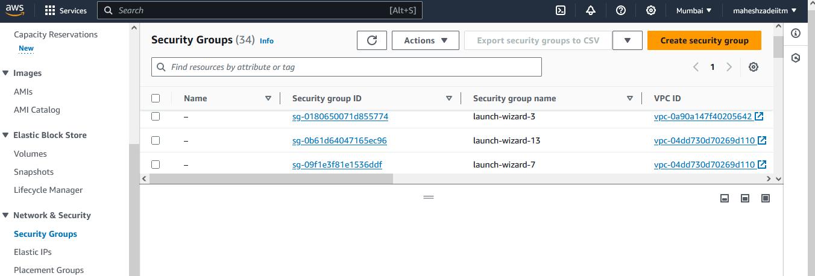

Open Security Groups >> Create

Security group name >> Mahesh-SG

Choose your VPC

Inbound rules >>> add rule

Type >>> http

Source >> anywhere

Create SG

Now Go to AWS Console EC2 Instance

2 - Launch my international EC2

Name - international

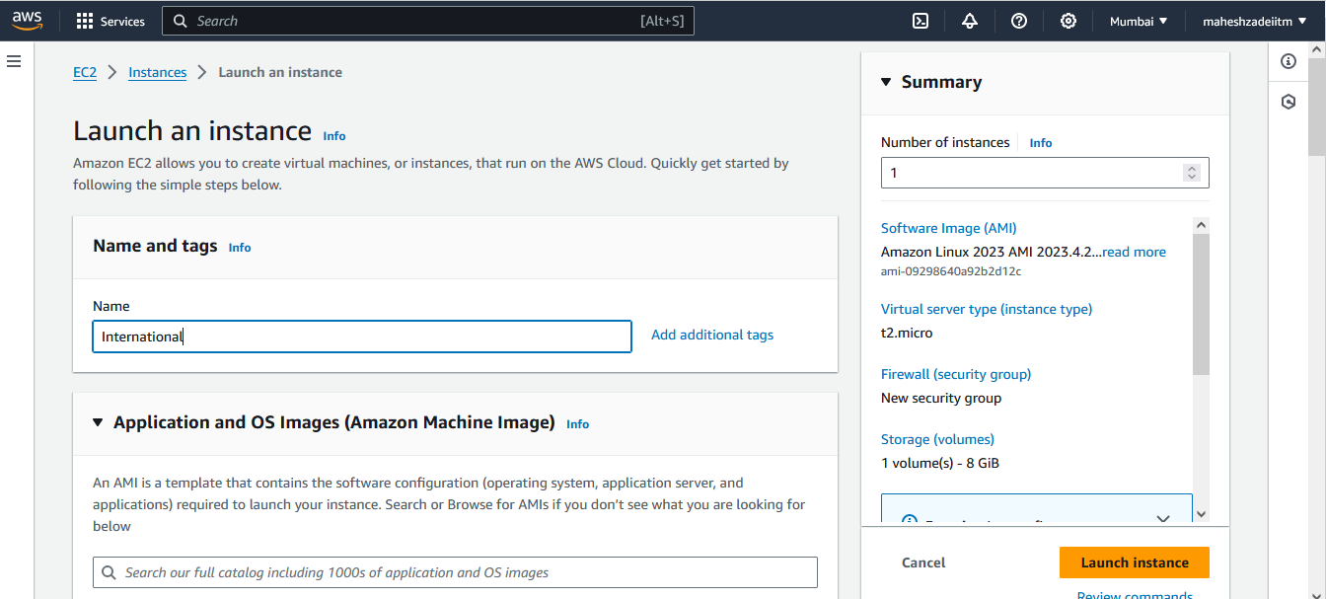

Browsee in AMI : AMI - "Amazon Linux 2" (Browse AMI)---Select

Instance type - t2.micro

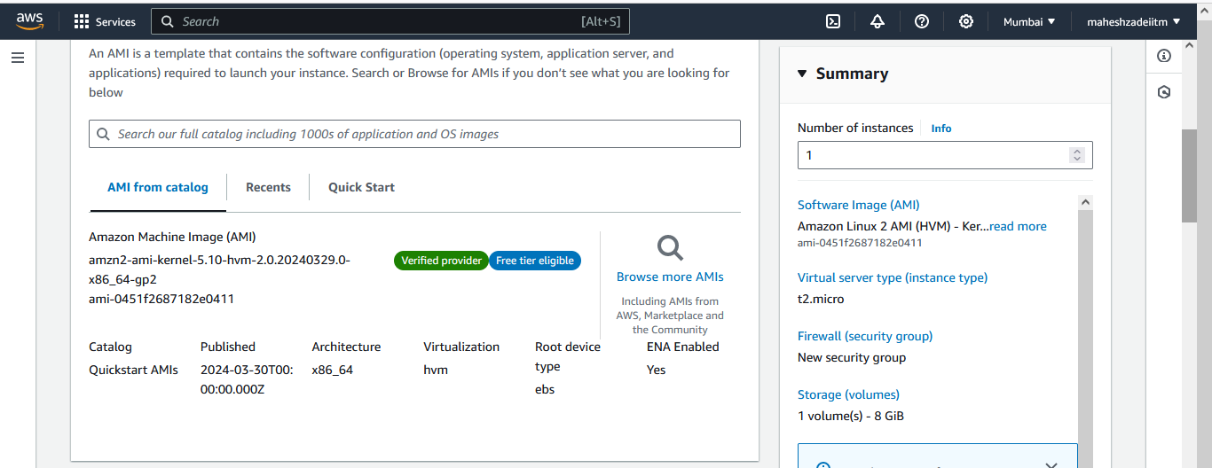

Keypair Mumbai Select

Choose your VPC and Choose Public Subnet Enable Public IP

Choose SG which you have created above >>> Select existing security group

Click on Advanced details >>> Scroll all the way down >>> update your user data

Launch Instance

3 - Launch my domestic EC2

Name - domestic

AMI - "Amazon Linux 2" (Browse AMI)

Instance type - t2.micro

Keypair choose

Choose your VPC ,Choose Public Subnet ,Enable Public IP

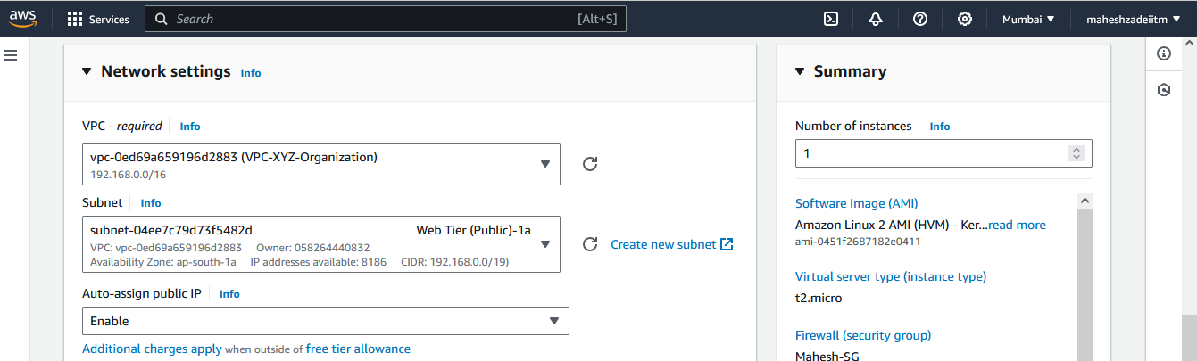

Choose SG which you have created above >>> Select existing security group

Click on Advanced details >>> Scroll all the way down >>> update your user data

Launch Instance

4 - Copy your individual Public Ips and try to access them

Type International after the IP address in the browser



Type domestic after the IP address in the browser

5 - Create a International TG

Create target group

Choose a target type >>> Instance

Target group name >>>> international

Protocol : Port >>>> HTTP

VPC >>>> Choose your VPC

Health checks >>>

Health check protocol >>> HTTP

Health check path >>>>international/index.html

Please Note - There should be only one "/", double check

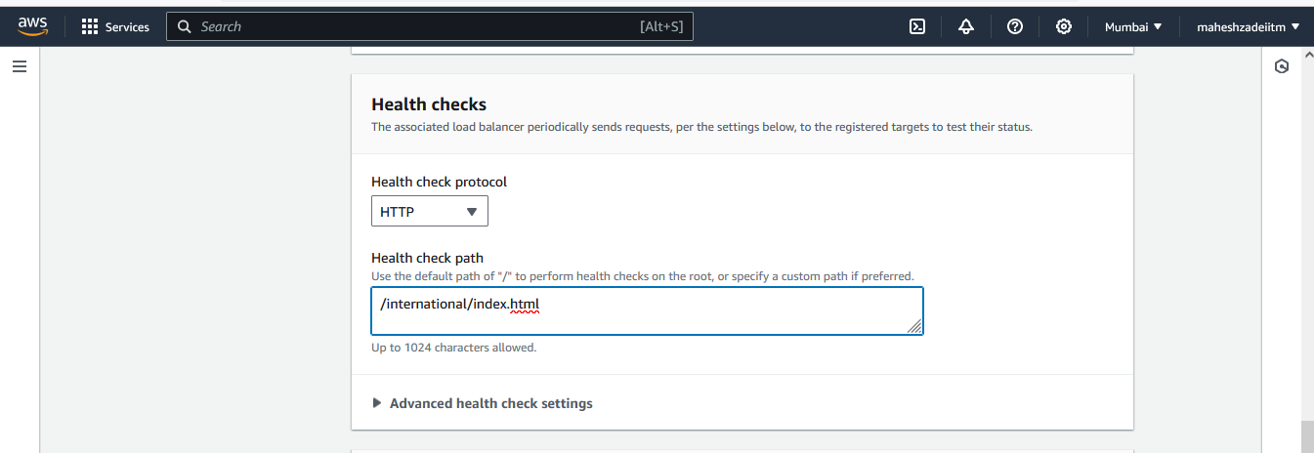

Next

Choose your International from your Available Instances >>> Include as pending below

Create target group

6 - Create a domestic TG

Create target group

Choose a target type >>> Instance

Target group name >>>> domestic

Protocol : Port >>>> HTTP

VPC >>>> Choose your VPC

Health checks >>>

Health check protocol >>> HTTP

Health check path >>>>domestic/index.html

Please Note - There should be only one "/", double check

Next

Choose your domestic from your Available Instances >>> Include as pending below

Create target group

7 - Create a ALB

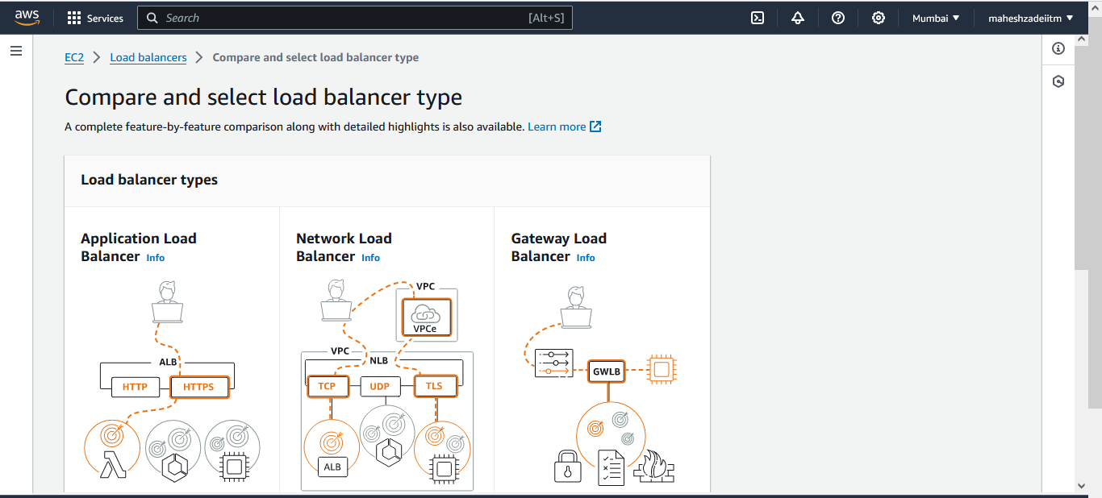

Click on create

Load balancer name >>> maheshapplication

Scheme >>> Internet-facing

Choose your VPC

Mappings >>> Choose your AZ >>> Cross verify yoour EC2 where you have launched

Choose min 2 AZ

Choose SG which you have created above

Listeners and routing

Default action >>> drop down >>> Choose International

Leave all the options and Create a Load balancer

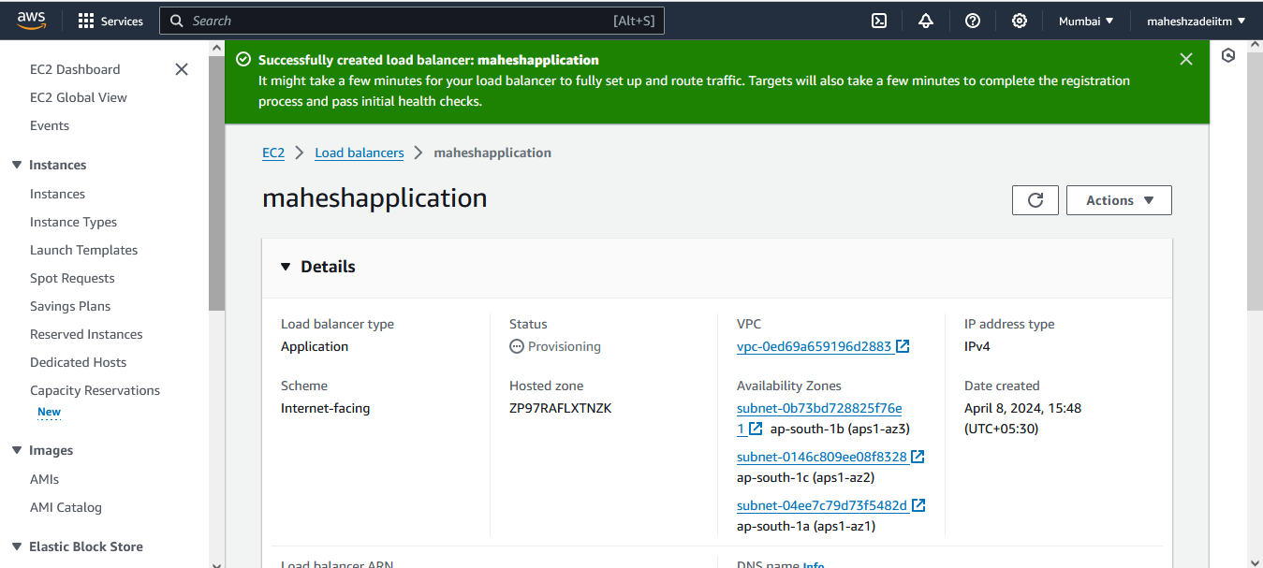

7A - you have to associate domestic TG as well

Go to the LB >>>> At the bottom >>> Listener and rule

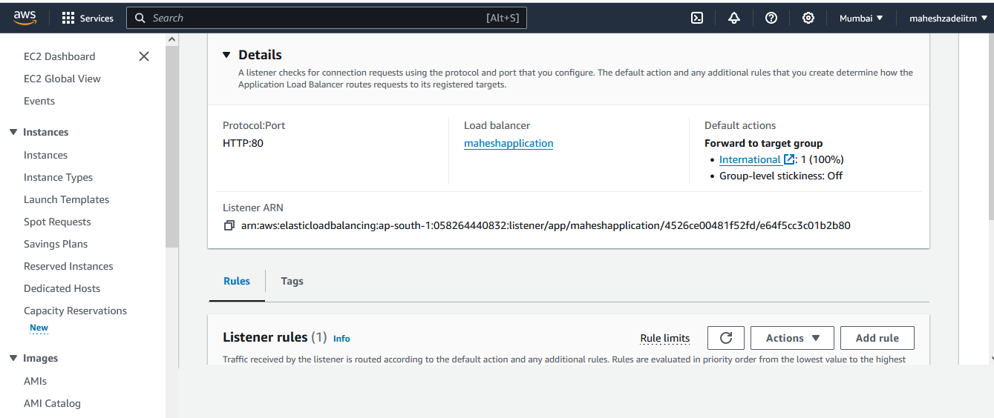

Click on that protocol >>> Manage Rule >>> Add Rule

Name >>> domestic

Next

Add Condition

Rule condition types >>>>> Path >>>> /domestic*

Confirm

Next

Action types

Forward to target groups

Target group >>> Choose domestic

Next

Priority >>> 1

Next

Create

Copy DNS Name from Maheshloadbalancer

Paste in browser

maheshapplication-387835366.ap-south-1.elb.amazonaws.com

maheshapplication-387835366.ap-south-1.elb.amazonaws.com/international

http://maheshapplication-387835366.ap-south-1.elb.amazonaws.com/domestic/

Elastic Load Balancer is working now .

Thanks

Pls check and update Security Group are configured properly, Application Load Balancer configured or nor , Customer VPC is configured properly or not ,

User data entry correct or not and also check the DNS URL is correct OR Not.